BCFA Club Admin Portal – Notes for Club Secretary
Season 24/25 has now been opened.
To update an existing team for the new season use the edit button and update the “Age Category”, the “Team Strength” and the “Playing Season”.
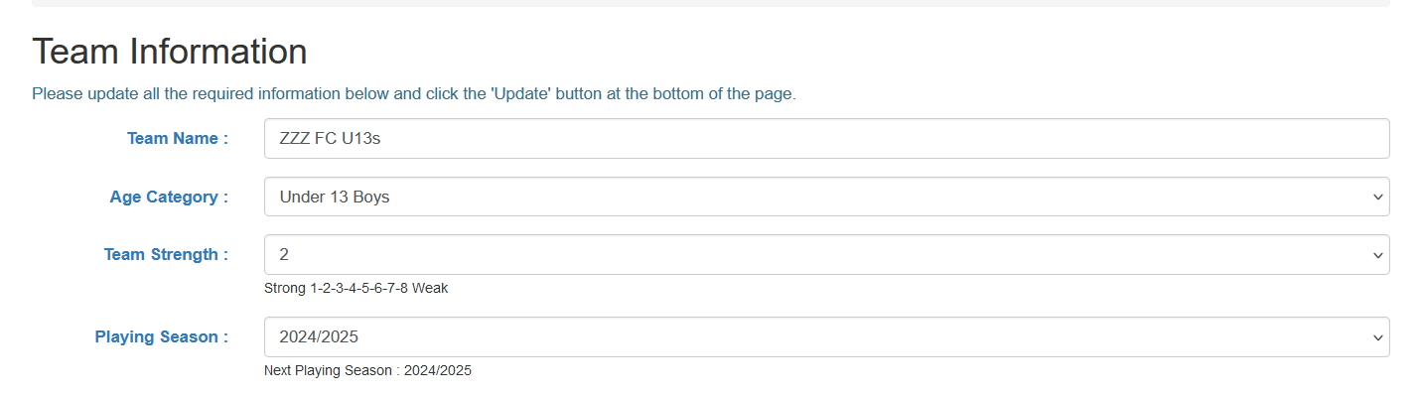
The age category in the team information tab should align to the age group category that the Club has submitted to your local County FA – see Q & A below for examples.
When in the Club Admin portal all fields in a section that are in blue font are Mandatory
You must complete all the Club sections in the Club Admin portal. Until you have completed this you will not be able to submit your League application.
Please enter mobile numbers starting with 0
If creating new teams please try to follow the naming convention already in use for your Club. It has been set this way to align with the naming convention in the FA Competition Portal to make cross verification of teams easier.
Where manager names are not known they may be defaulted to Unknown and require updating.
Where email addresses are not known they may be defaulted to tbc@tbc.com and require updating.
Please check in the portal frequently as this is where you can see any outstanding actions that you need to respond to and e.g. charges, fines or invoices.
If you have any issues or questions please email secretary@bcfayl.co.uk or call 07757753126 between 7pm - 8pm in the evening

Frequent Q & A
Q1 How to I setup a Girls Team that is playing down an Age Group
A1 Example girls team affiliated with County FA as an U9 Girls Team with team name of “Local Club Girls U9 Lionesses”. This would be set up in the Portal as below where the (D) in brackets informs the League that you want to team to play down an Age Group. So this team would be assigned to an U8 Division
Team Name Age Group Category
Local Club Girls Lionesses (D) U9 Girls
------------------------------------------------------------------------------------------------------------------------------------------------------------
Q2 How do I setup a Boys Team that is playing up an Age Group
A2 Following County FA guidance if a boys/mixed team wishes to play up an age group then they need to be affiliated with the County FA in the age group they will be playing. Example boys team affiliated as “Local Club U9 Reds”, when they are an U8 team playing up at U9. This would be set up in the Portal as below where the (U) in brackets informs the League that this team is playing up an Age Group. So this team would be assigned to an U9 division
Team Name Age Group Category
Local Club Reds (U) U9 Boys
------------------------------------------------------------------------------------------------------------------------------------------------------------
Q3 My team has folded before the season starts how can I get a membership refund
A3 Updates will be given in the News section
------------------------------------------------------------------------------------------------------------------------------------------------------------
Q4 Can I load my sponsor details against my team
A4 This functionality is currently being reviewed. Updates will be given in the News section
------------------------------------------------------------------------------------------------------------------------------------------------------------
Q5 My team has folded during the season how do I remove them
A5 When teams are going to fold during the season then you need to advise the League Secretary and the Age Group Fixture Secretary. Then in your Club Admin portal you need to update their status from active to inactive. The team will then go grey and still appear in your portal but at the bottom and will not show on the main website and would not be included in any portal downloads that the League schedule.
------------------------------------------------------------------------------------------------------------------------------------------------------------
Q6 My team is showing against the wrong division
A6 Contact the League Secretary who will arrange for the team to be moved to the correct Division
------------------------------------------------------------------------------------------------------------------------------------------------------------
Q7 My login is no longer working
A7 Contact the Secretary League who will regenerate a new unique login id
------------------------------------------------------------------------------------------------------------------------------------------------------------
Q8 I want another member of my Club to have access as they deal with a lot of the admin tasks
A8 In the Club Detail Section add them as an additional Secretary contact
------------------------------------------------------------------------------------------------------------------------------------------------------------
Q9 I am no longer the League Secretary for my Club
A9 Use Contact form to inform the League who will generate a new unique login for the replacement Club Secretary
------------------------------------------------------------------------------------------------------------------------------------------------------------
Q10 What do I need to do if I want to add a new non-competitive team to an U8 to U11 division once the season has started
A10 Make initial contact with the relevant Age Group Fixture Secretary. They will confirm when the next League update window to add a team will be. Before then complete all the new team affiliation requirements with County and advise secretary@bcfayl.co.uk that this has been completed. The League will then start the process of adding the team to an Age Group and you will be advised what action you need to do in your Club Admin Portal.
------------------------------------------------------------------------------------------------------------------------------------------------------------
Q11 What do I need to do if I want to add a new non-competitive team to the U7 Festivals once the season has started
A10 Make initial contact with the U7 Age Group Fixture Secretary. They will confirm when the next League workshop is scheduled as all U7 managers must attend one prior to the team starting. At the same time complete all the new team affiliation requirements with County and advise secretary@bcfayl.co.uk that this has been completed. The League will then start the process of adding the team to an Age Group and you will be advised what action you need to do in your Club Admin Portal.
------------------------------------------------------------------------------------------------------------------------------------------------------------

