BCFA League Guidance – Club Intentions Season 2024/25
The BCFA League Admin portals are now ready for Clubs to advise the League of their intentions for next season. Please follow the below guidance as the League will be using the admin portal information to draft the initial League constitutions.
The deadline for completing is Friday 17th May after which time the League will not be extracting from the portal FOR several weeks.
Please follow the 2 steps outlined below – “intention to continue” and “adding new team”.
If a Club has not updated any of its team by the deadline it will be assumed that the Club is planning to leave the League and none of the teams will be included in the draft constitution.
If you have any issues or queries please email the League portal admin secretary laurence.bough@bcfayl.co.uk or call 07757753126.

Intention to continue - process for existing teams in the BCFA League Season for 2023/24 to advise the League of whether a team will be continuing for Season 2024/25.
Login to your Club Admin portal and then Click on Team information – if you need the login reset contact League portal admin secretary
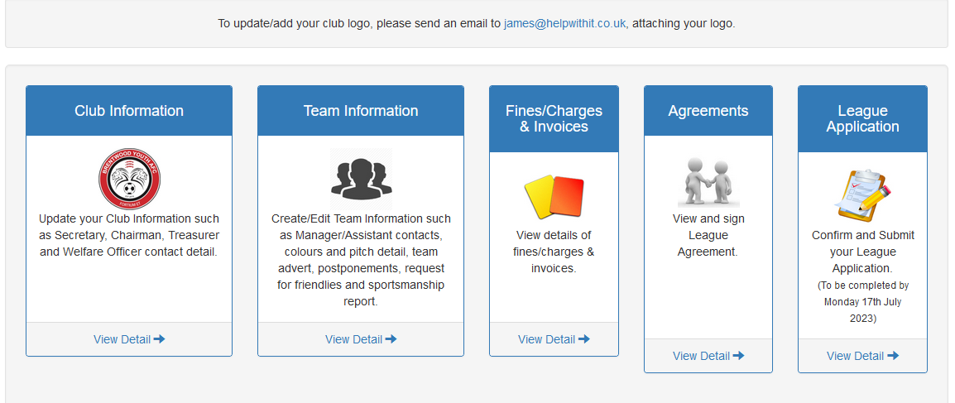
Now if the first team in your list of teams is continuing then select that team. If the first team is not rejoining the BCFA League then move onto the next team in your list
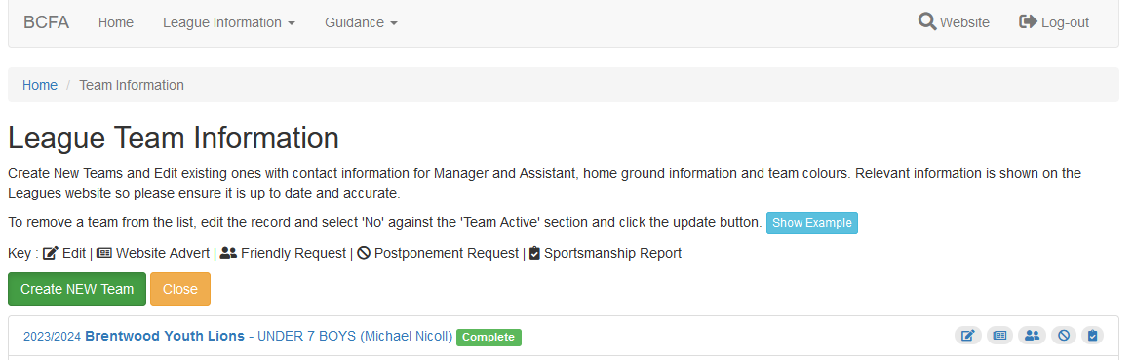

Now scroll down to the bottom of the team information where you will see the Intention option
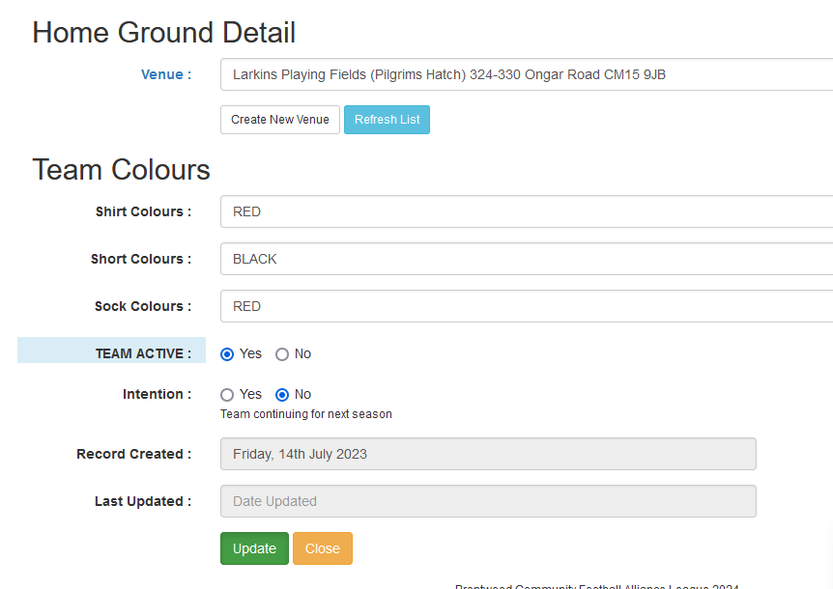

If the team is continuing, then click the “Yes” option and then press update. AT THIS POINT PLEASE DO NOT CHANGE ANY OTHER DETAIL FOR THE TEAM.
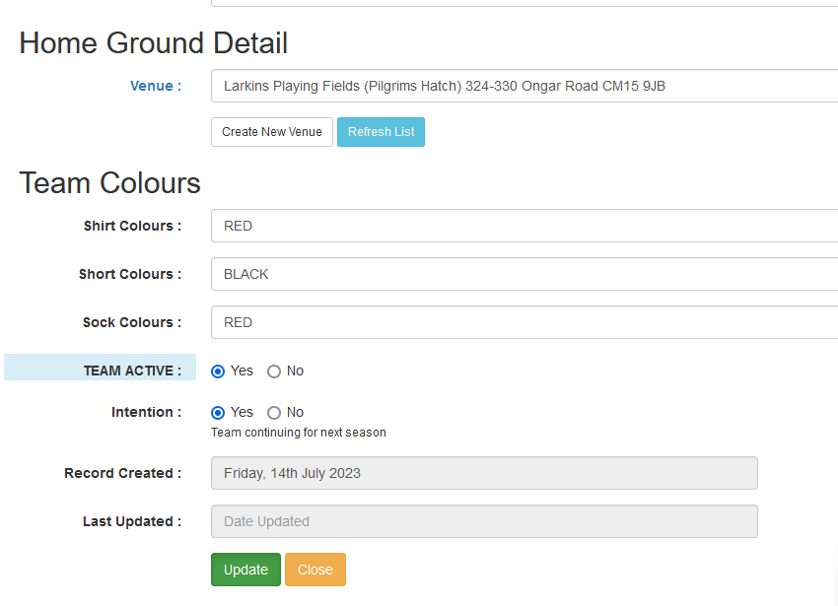
Continue until all existing teams in your portal have either had their intention updated to “Y” or left as “N”

Adding a new team - process for existing Clubs to add new teams to the BCFA League for Season 2024/25
If you want to advise the League that you have a new team that you would like to join the League then they should be added as below. It is important that this process is followed to allow the League to easily identify all prospective new teams.
From the Team list click on “Create New Team”
Now complete all fields that are in blue. All teams names must start with “NEW” (see also below for new girls teams). The Age Category selected should be the same one that the team will be affiliated under for Season 2024/25. If you do not know the name of the manager use the defaults as shown below. Once the 8 mandatory blue fields have been completed click on “Create New Record” and if more than 1 team repeat the process for each new team.
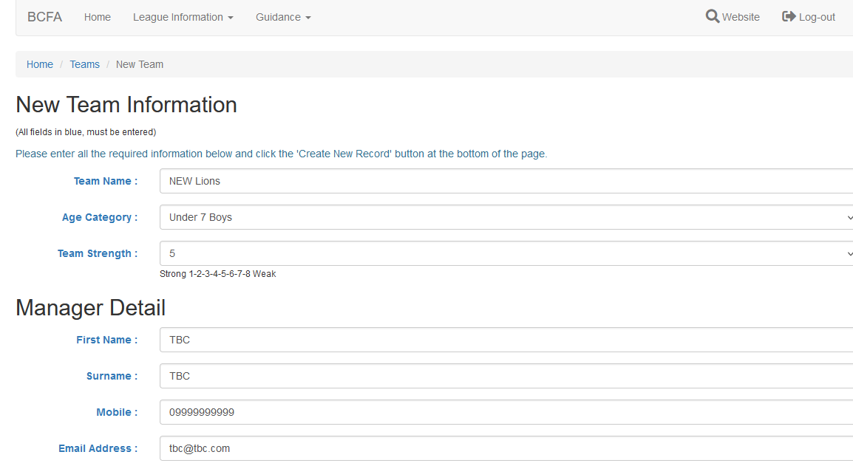
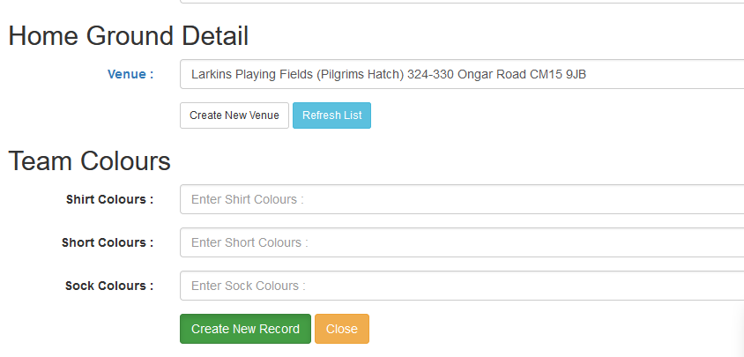

Example 2
If you are planning to enter a new Girls team who want to play down an age group then the team name should start “NEW DOWN”. In this example the new U10 Girls team would be added to one of the draft U9 constitutions.
